Assessment Name: In-Lab Exercise 03
Student Name: Vasukumar Patel
Lab Professor Name: Syed Bilgrami
Lab Section Number: 343
Due Date: October 29th

Task 1: Java Program: Translate the Algorithm into Java
(No need to put anything here. Just make sure to upload all .java files for In-Lab Exercise 03 on Brighspace.)

Task 2: UML Class Diagram
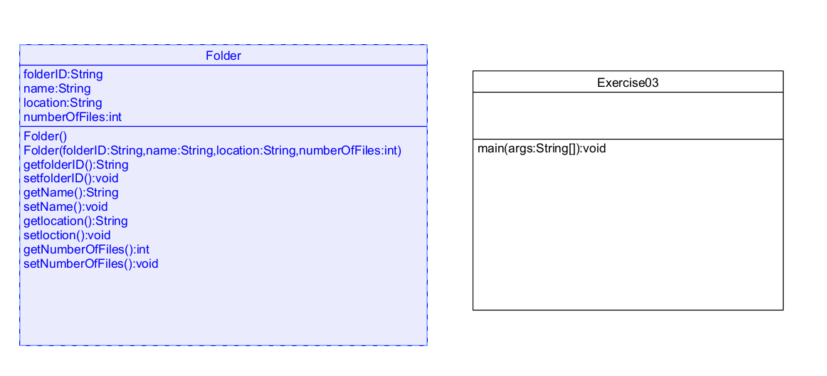
(Paste the UML class diagram here.)

Task 3: Compile and Test Your Program
(Paste a screenshot of your running program here.)

